**Lab Component Management System**

**A PROJECT REPORT**

***Submitted by***

**Shashank Bagda (92100133020)**

**Vivek Patel (92100133016)**

***In partial fulfillment for***

***OOP (01CT0105) Project***

**Sem – 2nd**

**Degree ENGINEERING**

***in***

**Information and Communication Technology Engineering**



**Faculty of Technology Studies**

**Marwadi University, Rajkot**

Acknowledgement

A successful project is a fruitfull culmination of efforts of many people, some directly involves while other that have quietly encouraged and extended their support while being in the background.

We are grateful to Prof Kapil Shukla (Prof at Marwadi University) not only for his invaluable guidance but also for his unending encouragement that he has given to us throughout the Java course and project. This work is a reflection of his teachings and expertise in the subject that he has passed on to us.

As a team we Shashank Bagda and Vivek Patel are submitting this document. We declare that the above acknowledgement and this documentation along with this project : “Lab Component Management” in its entirety is truthful, honest and in complete reflection of our work.

**Table of contents**

1 : Detail.

2 : Snapshots and code

Frame 1 : Home.

Frame 2 : Add Student (login).

Frame 3 : Component List.

Frame 4 : Validation Page.

Frame 5 : Return.

Frame 6 : About Us.

Frame 7 : Issue Successful.

Frame 8 : Return Successful.

Action Listener Code.

3 : Meeting with client

4 : Conclusion.

5 : Updated Code

Frame 3 : Component List

Action Listener Code

**1 :- Detail**

As per our client requirement we have make a project for the management of the component of lab. We have to store data of the student and transition’s done by them . If any component is broken then there will be fine on the student so total fine which is to be paid by the student is send on the mail.

For the record of student they have to write their Name, Enrollment Number and Email address. After filling all the details .txt file of that student will be created in the formate of 921001330XX.txt . Now if student want to issue components from lab they have to click on explore button. After that when student issues the component they will be asked for enrollement number . When they will give their enrollement number their record from .txt file and system will generate OTP and send it to the email recorded in the txt file of student. After verification of OTP new frame will be displayed showing successful issuing of component and also mail will be sent for the same.

For the return of component we have to enter the enrollement of the student and if component is damaged then number of damaged component. New Frame will be opened after ruterning of component showing return successfully and mail will be send for the same to mail in the record of student . If any component is broken then fine to be paid will be sent to the same gmail.

**2:- SnapShots and code**

**Frame 1 :- HOME PAGE.**

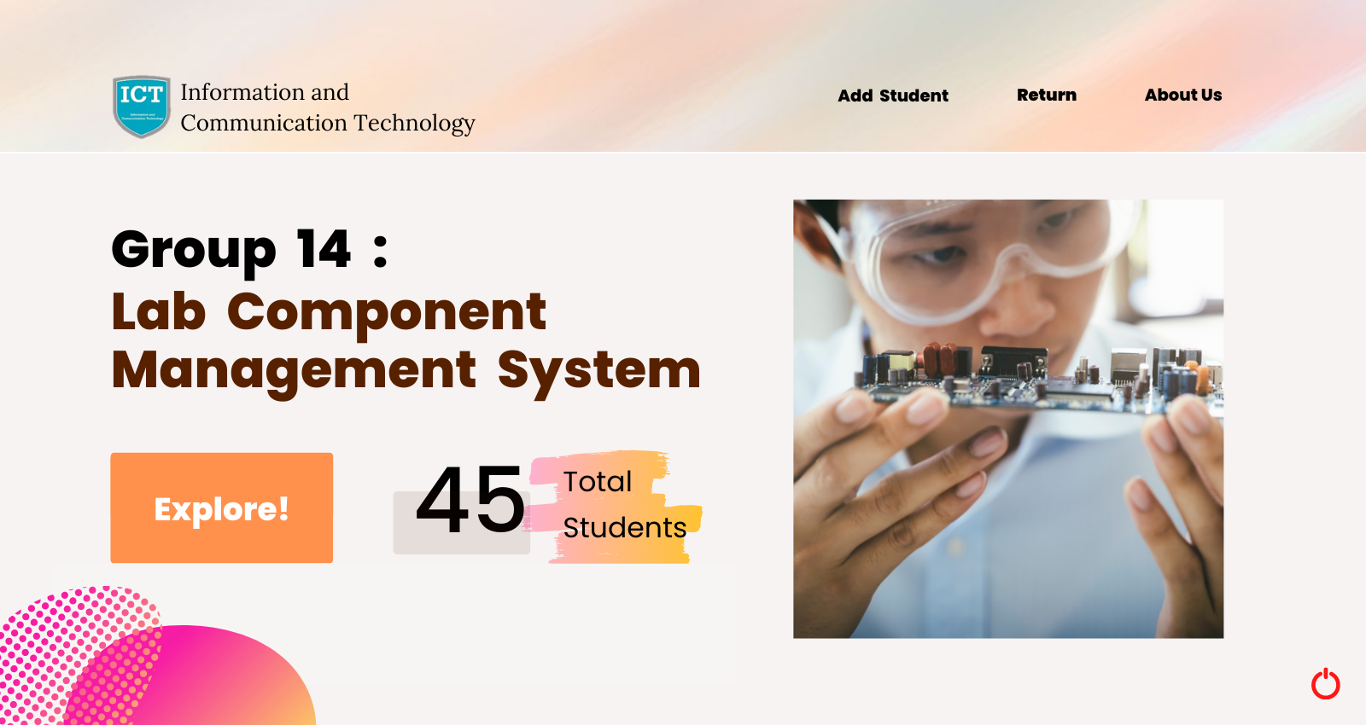

This frame is used as home screen. We can see total number of student added in the record. We can see 5 buttons in this frame that are as below

1:- Logout

2:-Add Student

3:- Return

4:- About Us

5:- Explore

Code:-

import java.awt.*;

import java.awt.event.*;

import java.io.*;

import javax.swing.*;

import java.lang.*;

import javax.swing.JFrame;

import java.io.IOException;

public class MyFrame extends Frame

{

JButton b1, b2, b3, b4, b5;

TextField t1;

Font f1;

MyActionListener ml;

MyFrame()

{

setLayout(null);

ml = new MyActionListener(this);

t1 = new TextField();

t1.setBounds(482,512,130,100);

Font f1 = new Font("Comic Sans MS",Font.BOLD,75);

t1.setFont(f1);

add(t1);

//Count Records

File directory = new File("D:\\OOP-Project\\Student Records\\Email");

int fileCount = directory.list().length;

t1.setText(new Integer(fileCount).toString());

JButton b1 = new JButton("myImage");

b1.setIcon(new ImageIcon(this.getClass().getResource("Images/homeb1.png")));

b1.setBounds(132,507,250,126);

add(b1);

b1.addActionListener(ml);

JButton b2=new JButton("Add Student");

b2.setIcon(new ImageIcon(this.getClass().getResource("Images/homeb2.png")));

b2.setBounds(968,50,156,50);

add(b2);

b2.addActionListener(ml);

JButton b3=new JButton("return");

b3.setIcon(new ImageIcon(this.getClass().getResource("Images/homeb3.png")));

b3.setBounds(1150,50,146,50);

add(b3);

b3.addActionListener(ml);

JButton b4=new JButton("abtus");

b4.setIcon(new ImageIcon(this.getClass().getResource("Images/homeb4.png")));

b4.setBounds(1332,50,156,50);

add(b4);

b4.addActionListener(ml);

JButton b5=new JButton("shut");

b5.setBackground(Color. WHITE);

b5.setIcon(new ImageIcon(this.getClass().getResource("Images/shut.png")));

b5.setBounds(1532,750,48,54);

add(b5);

b5.addActionListener(ml);

addWindowListener(new WindowAdapter()

{

public void windowClosing(WindowEvent we)

{

System.exit(0);

}

});

}

public void paint(Graphics g)

{

Toolkit t=Toolkit.getDefaultToolkit();

Image i=t.getImage("Images/home.png");

g.drawImage(i, 0, 0,this);

}

public static void main(String[] args)

{

MyFrame mf = new MyFrame();

mf.setExtendedState(mf.getExtendedState() | JFrame.MAXIMIZED_BOTH);

JFrame f=new JFrame();

f.add(mf);

f.setVisible(true);

}

}

**Frame 2 :- Add Student (Login)**

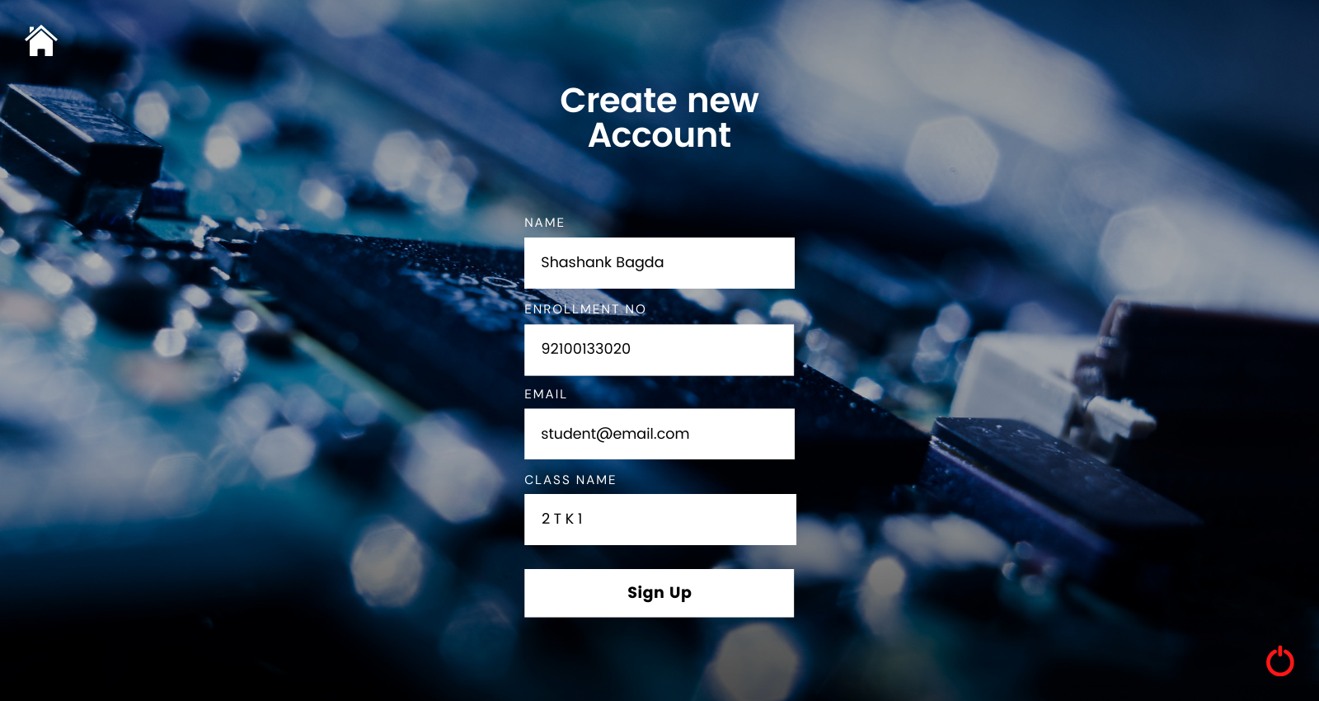

This frame is used for adding student in the txt files record. It has 4 text field and 3 buttons 1st button is for going to home page 2nd is for closing the GUI and 3rd is sign up for sigining the student.

import java.awt.*;

import java.awt.event.*;

import java.io.*;

import javax.swing.*;

import java.lang.*;

import javax.swing.JFrame;

public class MyFrame2 extends Frame

{

JButton b1, b2, b3;

TextField t1, t2, t3, t4;

MyActionListener ml;

MyFrame2()

{

setLayout(null);

ml = new MyActionListener(this);

JButton b1 = new JButton("AddStud");

b1.setIcon(new ImageIcon(this.getClass().getResource("Images/signupb1.png")));

b1.setBounds(635,666,326,56);

add(b1);

b1.addActionListener(ml);

JButton b2=new JButton("homepg");

b2.setBackground(Color. WHITE);

b2.setIcon(new ImageIcon(this.getClass().getResource("Images/signhome.png")));

b2.setBounds(28,0,48,50);

add(b2);

b2.addActionListener(ml);

JButton b3 = new JButton("shut");

b3.setIcon(new ImageIcon(this.getClass().getResource("Images/signshut.png")));

b3.setBounds(1532,750,48,54);

add(b3);

b3.addActionListener(ml);

t1 = new TextField();

t2 = new TextField();

t3 = new TextField();

t4 = new TextField();

t1.setBounds(635,266,326,56);

t2.setBounds(635,370,326,56);

t3.setBounds(635,472,326,56);

t4.setBounds(635,576,326,56);

add(t1);

add(t2);

add(t3);

add(t4);

addWindowListener(new WindowAdapter()

{

public void windowClosing(WindowEvent we)

{

System.exit(0);

}

});

}

public void paint(Graphics g)

{

Toolkit t=Toolkit.getDefaultToolkit();

Image i=t.getImage("Images/add.png");

g.drawImage(i, 0, 0,this);

}

}

**Frame 3:- Component List**

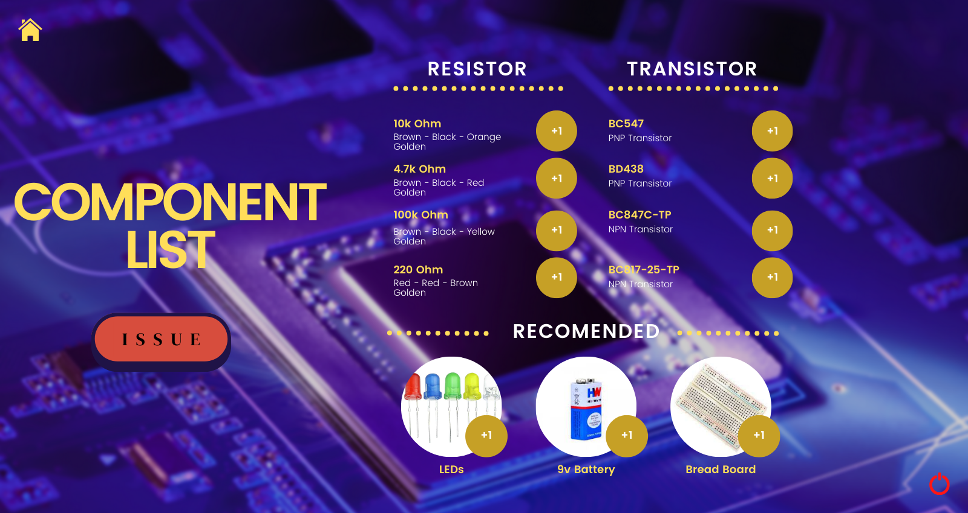

This fram is used for selecting the component and issuing the component there are total 14 button’s. 11 button’s are used for adding the component which student want to issue. One button is home and one is close. Issue button is used for issuing the selected component

import java.awt.*;

import java.awt.event.*;

import java.io.*;

import javax.swing.*;

import java.lang.*;

import javax.swing.JFrame;

import javax.swing.border.Border;

public class MyFrame1 extends Frame

{

JButton b1,b2,b3,b4,b5,b6,b7,b8,b9,b10,b11,b12,b13,b14;

MyActionListener ml;

MyFrame1()

{

setLayout(null);

ml = new MyActionListener(this);

JButton b1 = new JButton("Checkout");

b1.setIcon(new ImageIcon(this.getClass().getResource("Images/listb1.png")));

b1.setBounds(186,504,156,80);

add(b1);

b1.addActionListener(ml);

JButton b2 = new JButton("1");

b2.setIcon(new ImageIcon(this.getClass().getResource("Images/listb2.png")));

b2.setBounds(898, 172, 36, 38);

add(b2);

b2.addActionListener(ml);

JButton b3 = new JButton("2");

b3.setIcon(new ImageIcon(this.getClass().getResource("Images/listb2.png")));

b3.setBounds(898, 250, 36, 38);

add(b3);

b3.addActionListener(ml);

JButton b4 = new JButton("3");

b4.setIcon(new ImageIcon(this.getClass().getResource("Images/listb2.png")));

b4.setBounds(898, 340, 36, 38);

add(b4);

b4.addActionListener(ml);

JButton b5 = new JButton("4");

b5.setIcon(new ImageIcon(this.getClass().getResource("Images/listb2.png")));

b5.setBounds(898, 416, 36, 38);

add(b5);

b5.addActionListener(ml);

JButton b6 = new JButton("5");

b6.setIcon(new ImageIcon(this.getClass().getResource("Images/listb2.png")));

b6.setBounds(1256, 172, 36, 38);

add(b6);

b6.addActionListener(ml);

JButton b7 = new JButton("6");

b7.setIcon(new ImageIcon(this.getClass().getResource("Images/listb2.png")));

b7.setBounds(1256, 250, 36, 38);

add(b7);

b7.addActionListener(ml);

JButton b8 = new JButton("7");

b8.setIcon(new ImageIcon(this.getClass().getResource("Images/listb2.png")));

b8.setBounds(1256, 340, 36, 38);

add(b8);

b8.addActionListener(ml);

JButton b9 = new JButton("8");

b9.setIcon(new ImageIcon(this.getClass().getResource("Images/listb2.png")));

b9.setBounds(1256, 416, 36, 38);

add(b9);

b9.addActionListener(ml);

JButton b10 = new JButton("LED");

b10.setIcon(new ImageIcon(this.getClass().getResource("Images/listb2.png")));

b10.setBounds(784, 675, 36, 38);

add(b10);

b10.addActionListener(ml);

JButton b11 = new JButton("Battery");

b11.setIcon(new ImageIcon(this.getClass().getResource("Images/listb2.png")));

b11.setBounds(1016, 675, 36, 38);

add(b11);

b11.addActionListener(ml);

JButton b12 = new JButton("Board");

b12.setIcon(new ImageIcon(this.getClass().getResource("Images/listb2.png")));

b12.setBounds(1234, 675, 36, 38);

add(b12);

b12.addActionListener(ml);

JButton b13=new JButton("homepg");

b13.setBackground(Color. WHITE);

b13.setIcon(new ImageIcon(this.getClass().getResource("Images/listhome.png")));

b13.setBounds(28,0,48,50);

add(b13);

b13.addActionListener(ml);

JButton b14=new JButton("shut");

b14.setBackground(Color. WHITE);

b14.setIcon(new ImageIcon(this.getClass().getResource("Images/listshut.png")));

b14.setBounds(1532,750,48,54);

add(b14);

b14.addActionListener(ml);

addWindowListener(new WindowAdapter()

{

public void windowClosing(WindowEvent we)

{

System.exit(0);

}

});

}

public void paint(Graphics g)

{

Toolkit t=Toolkit.getDefaultToolkit();

Image i=t.getImage("Images/list.png");

g.drawImage(i, 0, 0,this);

}

}

**Frame 4:- Validation Page**

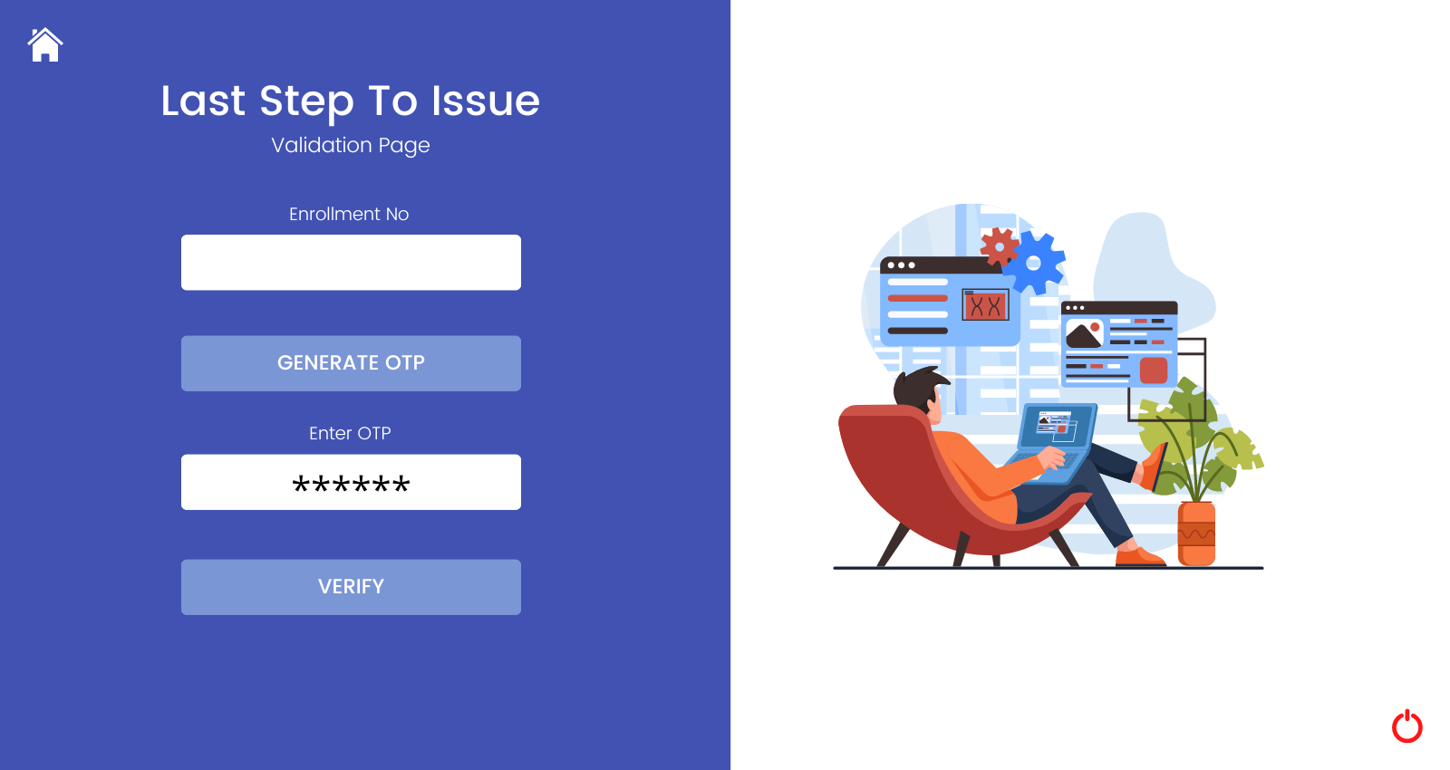

This frame is used for verification of student. It has 2 text box one is for entering enrolment number and other is for entering OTP.2 button is also used one is for generating OTP and another button is used here (VERIFY) after clicking that button student will be verified and component will be issued.

import java.awt.*;

import java.awt.event.*;

import java.io.*;

import javax.swing.*;

import java.lang.*;

import javax.swing.JFrame;

public class MyFrame4 extends Frame

{

JButton b1, b2;

TextField t1, t2;

Font f1;

MyActionListener ml;

MyFrame4()

{

setLayout(null);

ml = new MyActionListener(this);

t1 = new TextField();

t1.setBounds(200,236,370,56);

add(t1);

t2 = new TextField();

t2.setBounds(200,478,370,56);

add(t2);

Font f1 = new Font("Comic Sans MS",Font.BOLD,30);

t1.setFont(f1);

t2.setFont(f1);

JButton b1=new JButton("generate");

b1.setIcon(new ImageIcon(this.getClass().getResource("Images/gen.png")));

b1.setBounds(200,345,370,56);

add(b1);

b1.setVisible(true);

b1.addActionListener(ml);

JButton b2=new JButton("verify");

b2.setIcon(new ImageIcon(this.getClass().getResource("Images/ver.png")));

b2.setBounds(200,594,370,56);

add(b2);

b2.setVisible(true);

b2.addActionListener(ml);

JButton b3=new JButton("homepg");

b3.setIcon(new ImageIcon(this.getClass().getResource("Images/otphome.png")));

b3.setBounds(28,0,48,50);

add(b3);

b3.addActionListener(ml);

JButton b4 = new JButton("shut");

b4.setIcon(new ImageIcon(this.getClass().getResource("Images/otpshut.png")));

b4.setBounds(1532,750,48,54);

add(b4);

b4.addActionListener(ml);

addWindowListener(new WindowAdapter()

{

public void windowClosing(WindowEvent we)

{

System.exit(0);

}

});

}

public void paint(Graphics g)

{

Toolkit t=Toolkit.getDefaultToolkit();

Image i=t.getImage("Images/otp.png");

g.drawImage(i, 0, 0,this);

}

}

**Frame 5 :- Return**

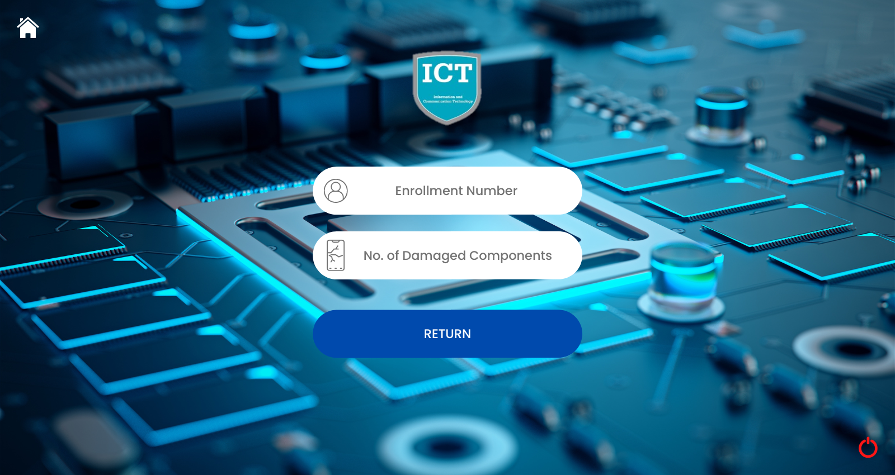

This frame is used for returning the component of student. There are two textfield one is for writing enrollement number and other is for writing the number of component broken. Three button are used one is for home screen second is for close and third button (return)is for returning the component.

|  |
| --- |
| import java.awt.*; |
|  | import java.awt.event.*; |
|  | import java.io.*; |
|  | import javax.swing.*; |
|  | import java.lang.*; |
|  | import javax.swing.JFrame; |
|  |  |
|  | public class MyFrame6 extends Frame |
|  | { |
|  | JButton b1,b2,b3; |
|  | TextField t1,t2; |
|  | MyActionListener ml; |
|  | MyFrame6() |
|  | { |
|  | setLayout(null); |
|  | ml = new MyActionListener(this); |
|  |  |
|  | t1 = new TextField(); |
|  | t2 = new TextField(); |
|  |  |
|  | t1.setBounds(625,278,374,70); |
|  | t2.setBounds(625,396,374,70); |
|  |  |
|  | Font f1 = new Font("Comic Sans MS",Font.BOLD,34); |
|  |  |
|  | t1.setFont(f1); |
|  | t2.setFont(f1); |
|  |  |
|  | add(t1); |
|  | add(t2); |
|  |  |
|  | JButton b1=new JButton("homepg"); |
|  | b1.setBackground(Color. WHITE); |
|  | b1.setIcon(new ImageIcon(this.getClass().getResource("Images/returnhome.png"))); |
|  | b1.setBounds(28,0,48,50); |
|  | add(b1); |
|  | b1.addActionListener(ml); |
|  |  |
|  | JButton b2 = new JButton("shut"); |
|  | b2.setIcon(new ImageIcon(this.getClass().getResource("Images/returnshut.png"))); |
|  | b2.setBounds(1532,750,48,54); |
|  | add(b2); |
|  | b2.addActionListener(ml); |
|  |  |
|  | JButton b3 = new JButton("retu"); |
|  | b3.setIcon(new ImageIcon(this.getClass().getResource("Images/returnb1.png"))); |
|  | b3.setBounds(600,530,400,78); |
|  | add(b3); |
|  | b3.addActionListener(ml); |
|  |  |
|  | addWindowListener(new WindowAdapter() |
|  | { |
|  | public void windowClosing(WindowEvent we) |
|  | { |
|  | System.exit(0); |
|  | } |
|  | }); |
|  | } |
|  |  |
|  | public void paint(Graphics g) |
|  | { |
|  | Toolkit t=Toolkit.getDefaultToolkit(); |
|  | Image i=t.getImage("Images/return.png"); |
|  | g.drawImage(i, 0, 0,this); |
|  | } |
|  | } |

**Frame 6:- About Us**

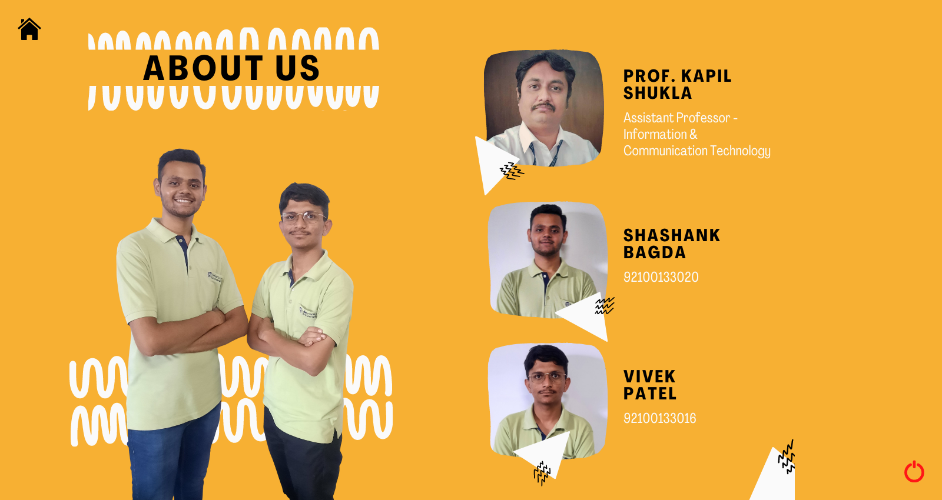

This frame is used for showing about us section.

|  |
| --- |
| import java.awt.*; |
|  | import java.awt.event.*; |
|  | import java.io.*; |
|  | import javax.swing.*; |
|  | import java.lang.*; |
|  | import javax.swing.JFrame; |
|  |  |
|  | public class MyFrame3 extends Frame |
|  | { |
|  | JButton b1,b2; |
|  | MyActionListener ml; |
|  | MyFrame3() |
|  | { |
|  | setLayout(null); |
|  | ml = new MyActionListener(this); |
|  |  |
|  | JButton b1=new JButton("homepg"); |
|  | b1.setBackground(Color. WHITE); |
|  | b1.setIcon(new ImageIcon(this.getClass().getResource("Images/abtushome.png"))); |
|  | b1.setBounds(28,0,48,50); |
|  | add(b1); |
|  | b1.addActionListener(ml); |
|  |  |
|  | JButton b2 = new JButton("shut"); |
|  | b2.setIcon(new ImageIcon(this.getClass().getResource("Images/abtusshut.png"))); |
|  | b2.setBounds(1532,750,48,54); |
|  | add(b2); |
|  | b2.addActionListener(ml); |
|  |  |
|  | addWindowListener(new WindowAdapter() |
|  | { |
|  | public void windowClosing(WindowEvent we) |
|  | { |
|  | System.exit(0); |
|  | } |
|  | }); |
|  | } |
|  |  |
|  | public void paint(Graphics g) |
|  | { |
|  | Toolkit t=Toolkit.getDefaultToolkit(); |
|  | Image i=t.getImage("Images/abtus.png"); |
|  | g.drawImage(i, 0, 0,this); |
|  | } |
|  | } |

**Frame 7 :- Issue Successful**



This frame is shown when issue of component is successfully done.

|  |
| --- |
| import java.awt.*; |
|  | import java.awt.event.*; |
|  | import java.io.*; |
|  | import javax.swing.*; |
|  | import java.lang.*; |
|  | import javax.swing.JFrame; |
|  |  |
|  | public class MyFrame5 extends Frame |
|  | { |
|  | JButton b1,b2; |
|  | MyActionListener ml; |
|  | MyFrame5() |
|  | { |
|  | setLayout(null); |
|  | ml = new MyActionListener(this); |
|  |  |
|  | JButton b1=new JButton("homepg"); |
|  | b1.setBackground(Color. WHITE); |
|  | b1.setIcon(new ImageIcon(this.getClass().getResource("Images/issuehome.png"))); |
|  | b1.setBounds(28,0,48,50); |
|  | add(b1); |
|  | b1.addActionListener(ml); |
|  |  |
|  | JButton b2 = new JButton("shut"); |
|  | b2.setIcon(new ImageIcon(this.getClass().getResource("Images/issueshut.png"))); |
|  | b2.setBounds(1532,750,48,54); |
|  | add(b2); |
|  | b2.addActionListener(ml); |
|  |  |
|  | addWindowListener(new WindowAdapter() |
|  | { |
|  | public void windowClosing(WindowEvent we) |
|  | { |
|  | System.exit(0); |
|  | } |
|  | }); |
|  | } |
|  |  |
|  | public void paint(Graphics g) |
|  | { |
|  | Toolkit t=Toolkit.getDefaultToolkit(); |
|  | Image i=t.getImage("Images/issue.png"); |
|  | g.drawImage(i, 0, 0,this); |
|  | } |
|  | } |

**Frame 8 :- Return Successful**



This frame is opened when return of the component is succefully done.

|  |
| --- |
| import java.awt.*; |
|  | import java.awt.event.*; |
|  | import java.io.*; |
|  | import javax.swing.*; |
|  | import java.lang.*; |
|  | import javax.swing.JFrame; |
|  |  |
|  | public class MyFrame7 extends Frame |
|  | { |
|  | JButton b1,b2; |
|  | MyActionListener ml; |
|  | MyFrame7() |
|  | { |
|  | setLayout(null); |
|  | ml = new MyActionListener(this); |
|  |  |
|  | JButton b1=new JButton("homepg"); |
|  | b1.setBackground(Color. WHITE); |
|  | b1.setIcon(new ImageIcon(this.getClass().getResource("Images/returnedhome.png"))); |
|  | b1.setBounds(28,0,48,50); |
|  | add(b1); |
|  | b1.addActionListener(ml); |
|  |  |
|  | JButton b2 = new JButton("shut"); |
|  | b2.setIcon(new ImageIcon(this.getClass().getResource("Images/returnedshut.png"))); |
|  | b2.setBounds(1532,750,48,54); |
|  | add(b2); |
|  | b2.addActionListener(ml); |
|  |  |
|  | addWindowListener(new WindowAdapter() |
|  | { |
|  | public void windowClosing(WindowEvent we) |
|  | { |
|  | System.exit(0); |
|  | } |
|  | }); |
|  | } |
|  |  |
|  | public void paint(Graphics g) |
|  | { |
|  | Toolkit t=Toolkit.getDefaultToolkit(); |
|  | Image i=t.getImage("Images/returned.png"); |
|  | g.drawImage(i, 0, 0,this); |
|  | } |
|  | } |

**Action Listener :-**

import java.lang.Long;

import java.awt.*;

import java.awt.event.*;

import java.io.*;

import javax.swing.*;

import java.lang.*;

import javax.swing.JFrame;

import java.util.*;

import java.time.format.DateTimeFormatter;

import java.time.LocalDateTime;

import java.nio.file.Files;

import java.nio.file.Path;

import java.io.BufferedReader;

import java.io.FileReader;

import java.io.IOException;

//set classpath=mail.jar;activation.jar;.;

import java.util.Properties;

import javax.mail.*;

import javax.mail.internet.*;

public class MyActionListener implements ActionListener

{

MyFrame mf;

MyFrame1 mf1;

MyFrame2 mf2;

MyFrame3 mf3;

MyFrame4 mf4;

MyFrame5 mf5;

MyFrame6 mf6;

MyFrame7 mf7;

String main, verr, b, tran;

int a, cot;

MyActionListener(MyFrame m)

{

this.mf = m;

}

MyActionListener(MyFrame1 m)

{

this.mf1 = m;

}

MyActionListener(MyFrame2 m)

{

this.mf2 = m;

}

MyActionListener(MyFrame3 m)

{

this.mf3 = m;

}

MyActionListener(MyFrame4 m)

{

this.mf4 = m;

}

MyActionListener(MyFrame5 m)

{

this.mf5 = m;

}

MyActionListener(MyFrame6 m)

{

this.mf6 = m;

}

MyActionListener(MyFrame7 m)

{

this.mf7 = m;

}

public void actionPerformed(ActionEvent e)

{

System.out.println(e.getActionCommand());

if(e.getActionCommand().equals("homepg"))

{

mf = new MyFrame();

this.mf.setVisible(true);

this.mf.setExtendedState(mf.getExtendedState() | JFrame.MAXIMIZED_BOTH);

this.mf1.setVisible(false);

this.mf2.setVisible(false);

this.mf3.setVisible(false);

this.mf4.setVisible(false);

this.mf5.setVisible(false);

this.mf6.setVisible(false);

this.mf7.setVisible(false);

File directory = new File("D:\\OOP-Project\\Student Records\\Email");

int fileCount = directory.list().length;

this.mf.t1.setText(new Integer(fileCount).toString());

}

if(e.getActionCommand().equals("shut"))

{

System.exit(0);

}

if(e.getActionCommand().equals("myImage"))

{

String z = new String("D:\\OOP-Project\\Records\\list.txt");

try

{

FileWriter fw = new FileWriter(z, false);

PrintWriter pw = new PrintWriter(fw, false);

pw.flush();

pw.close();

fw.close();

}

catch(Exception exception)

{

System.out.println("Exception have been caught");

}

mf1 = new MyFrame1();

this.mf1.setVisible(true);

this.mf1.setExtendedState(mf1.getExtendedState() | JFrame.MAXIMIZED_BOTH);

this.mf.setVisible(false);

}

if(e.getActionCommand().equals("Add Student"))

{

mf2 = new MyFrame2();

this.mf2.setVisible(true);

this.mf2.setExtendedState(mf2.getExtendedState() | JFrame.MAXIMIZED_BOTH);

this.mf.setVisible(false);

}

if(e.getActionCommand().equals("Checkout"))

{

mf4 = new MyFrame4();

this.mf4.setVisible(true);

this.mf4.setExtendedState(mf4.getExtendedState() | JFrame.MAXIMIZED_BOTH);

this.mf1.setVisible(false);

}

if(e.getActionCommand().equals("abtus"))

{

mf3 = new MyFrame3();

this.mf3.setVisible(true);

this.mf3.setExtendedState(mf3.getExtendedState() | JFrame.MAXIMIZED_BOTH);

this.mf.setVisible(false);

}

if(e.getActionCommand().equals("return"))

{

mf6 = new MyFrame6();

this.mf6.setVisible(true);

this.mf6.setExtendedState(mf6.getExtendedState() | JFrame.MAXIMIZED_BOTH);

this.mf.setVisible(false);

}

if(e.getActionCommand().equals("generate"))

{

String s = (this.mf4.t1.getText() + ".txt");

String z = new String("D:\\OOP-Project\\Student Records\\" + s);

String z2 = new String("D:\\OOP-Project\\Student Records\\Email\\" + s);

try

{

File myObj = new File(z2);

Scanner myReader = new Scanner(myObj);

while (myReader.hasNextLine())

{

String data = myReader.nextLine();

System.out.println(data);

this.main = data;

}

myReader.close();

}

catch (FileNotFoundException eqq)

{

System.out.println("An error occurred.");

eqq.printStackTrace();

}

long min = 000001;

long max = 999999;

double a = Math.random()*(max-min+1)+min;

int value = (int)a;

String code=Integer.toString(value);

this.verr = code;

System.out.println(verr);

String host="smtp.gmail.com";

final String user="shashank.bagda113475@marwadiuniversity.ac.in";

final String password="Cpdc@626";

String to=main;

//Get the session object

Properties props = new Properties();

props.put("mail.smtp.host",host);

props.put("mail.smtp.auth", "true");

props.put("mail.smtp.ssl.enable", "true");

Session session = Session.getDefaultInstance(props,

new javax.mail.Authenticator()

{

protected PasswordAuthentication getPasswordAuthentication()

{

return new PasswordAuthentication(user,password);

}

});

try

{

MimeMessage message = new MimeMessage(session);

message.setFrom(new InternetAddress(user));

message.addRecipient(Message.RecipientType.TO,new InternetAddress(to));

message.setSubject("Lab Component Management");

message.setText("Your OTP is : " + value);

Transport.send(message);

System.out.println("message sent successfully...");

}

catch (MessagingException exn)

{

exn.printStackTrace();

}

}

if(e.getActionCommand().equals("AddStud"))

{

mf = new MyFrame();

String name = this.mf2.t1.getText();

long Enroll = Long.parseLong(this.mf2.t2.getText());

String Mail = this.mf2.t3.getText();

String Cls = this.mf2.t4.getText();

System.out.println(name);

System.out.println(Enroll);

System.out.println(Mail);

System.out.println(Cls);

String s = new String("D:\\OOP-Project\\Student Records\\" + Enroll + ".txt");

File file = new File(s);

String s2 = new String("D:\\OOP-Project\\Student Records\\Email\\" + Enroll + ".txt");

File file2 = new File(s2);

boolean result;

try

{

result = file.createNewFile();

if(result)

{

System.out.println("file created "+file.getCanonicalPath());

FileWriter myWriter = new FileWriter(s);

myWriter.write(name + " - " + Cls);

myWriter.close();

}

else

{

System.out.println("File already exist at location: "+file.getCanonicalPath());

}

}

catch (IOException est)

{

est.printStackTrace();

}

boolean result2;

try

{

result2 = file2.createNewFile();

if(result2)

{

System.out.println("file created "+file2.getCanonicalPath());

FileWriter myWriter2 = new FileWriter(s2);

myWriter2.write(Mail);

myWriter2.close();

}

else

{

System.out.println("File already exist at location: "+file2.getCanonicalPath());

}

}

catch (IOException est2)

{

est2.printStackTrace();

}

File directory = new File("D:\\OOP-Project\\Student Records");

int fileCount = directory.list().length;

this.mf.t1.setText(new Integer(fileCount-1).toString());

this.mf.setVisible(true);

this.mf.setExtendedState(mf.getExtendedState() | JFrame.MAXIMIZED_BOTH);

this.mf2.setVisible(false);

}

if(e.getActionCommand().equals("1"))

{

String z = new String("D:\\OOP-Project\\Records\\list.txt");

try

{

FileWriter myWriter = new FileWriter(z, true);

myWriter.write("10k Ohm");

myWriter.write("\n");

myWriter.close();

}

catch (IOException est)

{

est.printStackTrace();

}

}

if(e.getActionCommand().equals("2"))

{

String z = new String("D:\\OOP-Project\\Records\\list.txt");

try

{

FileWriter myWriter = new FileWriter(z, true);

myWriter.write("4.7k Ohm");

myWriter.write("\n");

myWriter.close();

}

catch (IOException est)

{

est.printStackTrace();

}

}

if(e.getActionCommand().equals("3"))

{

String z = new String("D:\\OOP-Project\\Records\\list.txt");

try

{

FileWriter myWriter = new FileWriter(z, true);

myWriter.write("100k Ohm");

myWriter.write("\n");

myWriter.close();

}

catch (IOException est)

{

est.printStackTrace();

}

}

if(e.getActionCommand().equals("4"))

{

String z = new String("D:\\OOP-Project\\Records\\list.txt");

try

{

FileWriter myWriter = new FileWriter(z, true);

myWriter.write("220k Ohm");

myWriter.write("\n");

myWriter.close();

}

catch (IOException est)

{

est.printStackTrace();

}

}

if(e.getActionCommand().equals("5"))

{

String z = new String("D:\\OOP-Project\\Records\\list.txt");

try

{

FileWriter myWriter = new FileWriter(z, true);

myWriter.write("BC547");

myWriter.write("\n");

myWriter.close();

}

catch (IOException est)

{

est.printStackTrace();

}

}

if(e.getActionCommand().equals("6"))

{

String z = new String("D:\\OOP-Project\\Records\\list.txt");

try

{

FileWriter myWriter = new FileWriter(z, true);

myWriter.write("BD438");

myWriter.write("\n");

myWriter.close();

}

catch (IOException est)

{

est.printStackTrace();

}

}

if(e.getActionCommand().equals("7"))

{

String z = new String("D:\\OOP-Project\\Records\\list.txt");

try

{

FileWriter myWriter = new FileWriter(z, true);

myWriter.write("BC847C - TP");

myWriter.write("\n");

myWriter.close();

}

catch (IOException est)

{

est.printStackTrace();

}

}

if(e.getActionCommand().equals("8"))

{

String z = new String("D:\\OOP-Project\\Records\\list.txt");

try

{

FileWriter myWriter = new FileWriter(z, true);

myWriter.write("BC817 - 25 - TP");

myWriter.write("\n");

myWriter.close();

}

catch (IOException est)

{

est.printStackTrace();

}

}

if(e.getActionCommand().equals("LED"))

{

String z = new String("D:\\OOP-Project\\Records\\list.txt");

try

{

FileWriter myWriter = new FileWriter(z, true);

myWriter.write("LED");

myWriter.write("\n");

myWriter.close();

}

catch (IOException est)

{

est.printStackTrace();

}

}

if(e.getActionCommand().equals("Battery"))

{

String z = new String("D:\\OOP-Project\\Records\\list.txt");

try

{

FileWriter myWriter = new FileWriter(z, true);

myWriter.write("Battery");

myWriter.write("\n");

myWriter.close();

}

catch (IOException est)

{

est.printStackTrace();

}

}

if(e.getActionCommand().equals("Board"))

{

String z = new String("D:\\OOP-Project\\Records\\list.txt");

try

{

FileWriter myWriter = new FileWriter(z, true);

myWriter.write("Board");

myWriter.write("\n");

myWriter.close();

}

catch (IOException est)

{

est.printStackTrace();

}

}

if(e.getActionCommand().equals("verify"))

{

String s = (this.mf4.t1.getText() + ".txt");

String z2 = new String("D:\\OOP-Project\\Student Records\\Email\\" + s);

String z3 = new String("D:\\OOP-Project\\Student Records\\" + s);

String host="smtp.gmail.com";

final String user="shashank.bagda113475@marwadiuniversity.ac.in";

final String password="Cpdc@626";

String to=main;

//Get the session object

Properties props = new Properties();

props.put("mail.smtp.host",host);

props.put("mail.smtp.auth", "true");

props.put("mail.smtp.ssl.enable", "true");

Session session = Session.getDefaultInstance(props,

new javax.mail.Authenticator()

{

protected PasswordAuthentication getPasswordAuthentication()

{

return new PasswordAuthentication(user,password);

}

});

try

{

DateTimeFormatter dtf = DateTimeFormatter.ofPattern("dd/MM/yyyy HH:mm:ss");

LocalDateTime now = LocalDateTime.now();

String time = (dtf.format(now)).toString();

char ch[] = new char[500];

FileReader fr = new FileReader("D:\\OOP-Project\\Records\\list.txt");

fr.read(ch);

fr.close();

String records = new String(ch);

String record[] = records.split(" ");

//int srNo = 1;

FileWriter fw=new FileWriter(z3,true);

fw.write("\n\n");

fw.write("ISSUED SUCCESSFULLY - " + time);

fw.write("\n\n");

for(int loop=0; loop<record.length ;loop++)

{

fw.write(""+record[loop]);

}

fw.close();

MimeMessage message = new MimeMessage(session);

message.setFrom(new InternetAddress(user));

message.addRecipient(Message.RecipientType.TO,new InternetAddress(to));

message.setSubject("Lab Component Management");

message.setText("Components Issued Successfully on "+ time +"\n\nList of Components is given below" + "\n\n" + records);

Transport.send(message);

System.out.println("message sent successfully...");

mf5 = new MyFrame5();

this.mf5.setVisible(true);

this.mf5.setExtendedState(mf5.getExtendedState() | JFrame.MAXIMIZED_BOTH);

this.mf4.setVisible(false);

}

catch (MessagingException exn)

{

exn.printStackTrace();

}

catch (Exception aa)

{

System.out.println(aa);

}

}

if(e.getActionCommand().equals("retu"))

{

String s = (this.mf6.t1.getText() + ".txt");

String num = (this.mf6.t2.getText());

String z = new String("D:\\OOP-Project\\Student Records\\" + s);

int value = Integer.parseInt(this.mf6.t2.getText());

try

{

DateTimeFormatter dtf = DateTimeFormatter.ofPattern("dd/MM/yyyy HH:mm:ss");

LocalDateTime now = LocalDateTime.now();

String time = (dtf.format(now)).toString();

FileWriter myWriter = new FileWriter(z, true);

myWriter.write("\n\nRETURNED SUCCESSFULLY - " + time + "\nPenalty - " + value*5);

myWriter.close();

FileReader fr=new FileReader("D:\\OOP-Project\\Records\\transaction.txt");

int i;

while((i=fr.read())!=-1)

this.a = a+1;

FileWriter myWriter3 = new FileWriter("D:\\OOP-Project\\Records\\transaction.txt");

myWriter3.write(String.valueOf(a));

myWriter3.close();

fr.close();

}

catch (IOException est1)

{

est1.printStackTrace();

}

String z2 = new String("D:\\OOP-Project\\Student Records\\Email\\" + s);

try

{

File myObj = new File(z2);

Scanner myReader = new Scanner(myObj);

while (myReader.hasNextLine())

{

String data = myReader.nextLine();

System.out.println(data);

this.main = data;

}

myReader.close();

}

catch (FileNotFoundException eqq)

{

System.out.println("An error occurred.");

eqq.printStackTrace();

}

String host="smtp.gmail.com";

final String user="shashank.bagda113475@marwadiuniversity.ac.in";

final String password="Cpdc@626";

String to=main;

//Get the session object

Properties props = new Properties();

props.put("mail.smtp.host",host);

props.put("mail.smtp.auth", "true");

props.put("mail.smtp.ssl.enable", "true");

Session session = Session.getDefaultInstance(props,

new javax.mail.Authenticator()

{

protected PasswordAuthentication getPasswordAuthentication()

{

return new PasswordAuthentication(user,password);

}

});

try

{

MimeMessage message = new MimeMessage(session);

message.setFrom(new InternetAddress(user));

message.addRecipient(Message.RecipientType.TO,new InternetAddress(to));

message.setSubject("Lab Component Management");

message.setText("Dear Student, \nYou have SUCCESSFULLY RETURNED Components...\nYou have to pay " + value*5 + " to the Administration."+ "\nKeep Learning");

Transport.send(message);

System.out.println("message sent successfully...");

}

catch (MessagingException exn)

{

exn.printStackTrace();

}

mf7 = new MyFrame7();

this.mf7.setVisible(true);

this.mf7.setExtendedState(mf7.getExtendedState() | JFrame.MAXIMIZED_BOTH);

this.mf6.setVisible(false);

}

}

}

**3 : -Meeting with client**

Client Name:-

Yash Vara (92100133056)

Jyot Joshi (92100133003)

First Meet :-

In this meeting our client had given use the project definition nad gave us briefing about what they want in this project to be included.

Second Meet :-

Second meet was conducted after our GUI was ready. We had showen our client Class and GUI. They gave us suggestion for adding some more images and show total number of student using this system.

Third Meet :-

Third meet was done after completion of our action listener. The client have asked to use for things like different fine on different component if they are broken and show the total number of items in the cart before issuing.

**4 :- Conclusion**

In this project we have learned about java language in deep. We got to know many new thing like sending gmail to any student’s gmail by just entering his\her enrollement number system will find gmail address from the txt file saved. We have learned how to generate OTP. How to put image in the background and on the button.

**5 : Updated Code**

**FRAME 3 :**

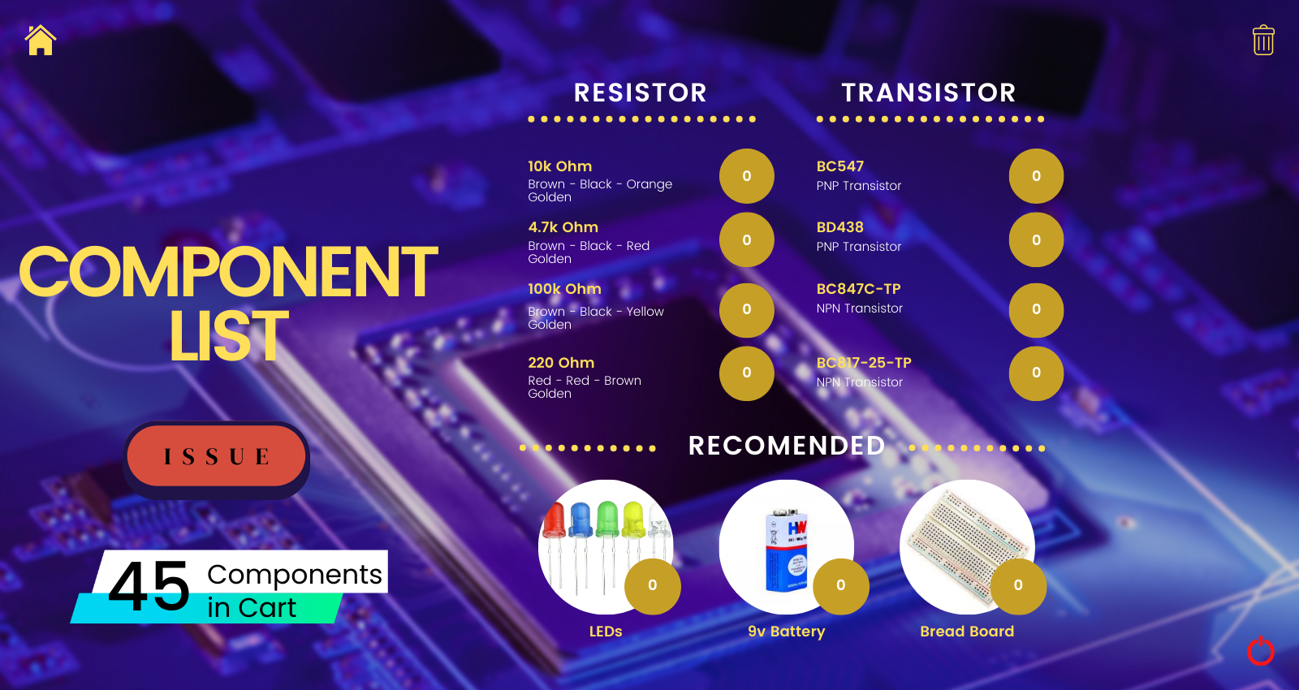

Here I added an extra feature which shows the total number of components you are going to issue. It can be seen as the number of items added to cart. Also I created 0 to 10 button icons which represent the issued components. Like if we take 5 battery then the circle representing the battery shows 5. Here are the images…

          

Also added on additional Delete button on the top right side of the frame, which will delete the last issued component from the list and also update the text field which represent the Cart.

**This changes are suggested by the IT Team of the Marwadi University on the day of Project Demostration and I successfully implemented it.**

**CODE :**

import java.awt.*;

import java.awt.event.*;

import java.io.*;

import javax.swing.*;

import java.lang.*;

import javax.swing.JFrame;

import javax.swing.border.Border;

public class MyFrame1 extends Frame

{

JButton b1,b2,b3,b4,b5,b6,b7,b8,b9,b10,b11,b12,b13,b14,b15;

TextField t1;

int cart=0;

MyActionListener ml;

MyFrame1()

{

setLayout(null);

ml = new MyActionListener(this);

t1 = new TextField();

t1.setBounds(128,655,104,80);

Font f1 = new Font("Comic Sans MS",Font.BOLD,75);

t1.setFont(f1);

add(t1);

t1.setText("" + cart);

JButton b1 = new JButton("Checkout");

b1.setIcon(new ImageIcon(this.getClass().getResource("Images/listb1.png")));

b1.setBounds(186,504,156,80);

add(b1);

b1.addActionListener(ml);

JButton b2 = new JButton("1");

b2.setIcon(new ImageIcon(this.getClass().getResource("Images/0.png")));

b2.setBounds(898, 172, 36, 38);

add(b2);

b2.addActionListener(ml);

JButton b3 = new JButton("2");

b3.setIcon(new ImageIcon(this.getClass().getResource("Images/0.png")));

b3.setBounds(898, 250, 36, 38);

add(b3);

b3.addActionListener(ml);

JButton b4 = new JButton("3");

b4.setIcon(new ImageIcon(this.getClass().getResource("Images/0.png")));

b4.setBounds(898, 340, 36, 38);

add(b4);

b4.addActionListener(ml);

JButton b5 = new JButton("4");

b5.setIcon(new ImageIcon(this.getClass().getResource("Images/0.png")));

b5.setBounds(898, 416, 36, 38);

add(b5);

b5.addActionListener(ml);

JButton b6 = new JButton("5");

b6.setIcon(new ImageIcon(this.getClass().getResource("Images/0.png")));

b6.setBounds(1256, 172, 36, 38);

add(b6);

b6.addActionListener(ml);

JButton b7 = new JButton("6");

b7.setIcon(new ImageIcon(this.getClass().getResource("Images/0.png")));

b7.setBounds(1256, 250, 36, 38);

add(b7);

b7.addActionListener(ml);

JButton b8 = new JButton("7");

b8.setIcon(new ImageIcon(this.getClass().getResource("Images/0.png")));

b8.setBounds(1256, 340, 36, 38);

add(b8);

b8.addActionListener(ml);

JButton b9 = new JButton("8");

b9.setIcon(new ImageIcon(this.getClass().getResource("Images/0.png")));

b9.setBounds(1256, 416, 36, 38);

add(b9);

b9.addActionListener(ml);

JButton b10 = new JButton("LED");

b10.setIcon(new ImageIcon(this.getClass().getResource("Images/0.png")));

b10.setBounds(784, 675, 36, 38);

add(b10);

b10.addActionListener(ml);

JButton b11 = new JButton("Battery");

b11.setIcon(new ImageIcon(this.getClass().getResource("Images/0.png")));

b11.setBounds(1016, 675, 36, 38);

add(b11);

b11.addActionListener(ml);

JButton b12 = new JButton("Board");

b12.setIcon(new ImageIcon(this.getClass().getResource("Images/0.png")));

b12.setBounds(1234, 675, 36, 38);

add(b12);

b12.addActionListener(ml);

JButton b13=new JButton("homepg");

b13.setBackground(Color. WHITE);

b13.setIcon(new ImageIcon(this.getClass().getResource("Images/listhome.png")));

b13.setBounds(28,0,48,50);

add(b13);

b13.addActionListener(ml);

JButton b14=new JButton("shut");

b14.setBackground(Color. WHITE);

b14.setIcon(new ImageIcon(this.getClass().getResource("Images/listshut.png")));

b14.setBounds(1532,750,48,54);

add(b14);

b14.addActionListener(ml);

JButton b15=new JButton("delete");

b15.setIcon(new ImageIcon(this.getClass().getResource("Images/listdel.png")));

b15.setBounds(1532,0,48,54);

add(b15);

b15.addActionListener(ml);

addWindowListener(new WindowAdapter()

{

public void windowClosing(WindowEvent we)

{

System.exit(0);

}

});

}

public void paint(Graphics g)

{

Toolkit t=Toolkit.getDefaultToolkit();

Image i=t.getImage("Images/list.png");

g.drawImage(i, 0, 0,this);

}

}

**Action Listener :**

Another update I did in my code is, I added **touch sound,** which means when we click any of the button it will play a pop sound. Which makes the frame more intereactive to the user and also becomes more catchy to intereacting person.

**CODE :**

import java.lang.Long;

import java.awt.*;

import java.awt.event.*;

import java.io.*;

import javax.swing.*;

import java.lang.*;

import javax.swing.JFrame;

import java.util.*;

import java.time.format.DateTimeFormatter;

import java.time.LocalDateTime;

import java.nio.file.Files;

import java.nio.file.Path;

import java.io.BufferedReader;

import java.io.FileReader;

import java.io.IOException;

import sun.audio.*;

import javax.script.*;

//set classpath=mail.jar;activation.jar;.;

import java.util.Properties;

import javax.mail.*;

import javax.mail.internet.*;

public class MyActionListener implements ActionListener

{

MyFrame mf;

MyFrame1 mf1;

MyFrame2 mf2;

MyFrame3 mf3;

MyFrame4 mf4;

MyFrame5 mf5;

MyFrame6 mf6;

MyFrame7 mf7;

String main, verr, b, tran;

int a, cot, bu2=1, bu3=1, bu4=1, bu5=1, bu6=1, bu7=1, bu8=1, bu9=1, bu10=1, bu11=1, bu12=1;

MyActionListener(MyFrame m)

{

this.mf = m;

}

MyActionListener(MyFrame1 m)

{

this.mf1 = m;

}

MyActionListener(MyFrame2 m)

{

this.mf2 = m;

}

MyActionListener(MyFrame3 m)

{

this.mf3 = m;

}

MyActionListener(MyFrame4 m)

{

this.mf4 = m;

}

MyActionListener(MyFrame5 m)

{

this.mf5 = m;

}

MyActionListener(MyFrame6 m)

{

this.mf6 = m;

}

MyActionListener(MyFrame7 m)

{

this.mf7 = m;

}

public void actionPerformed(ActionEvent e)

{

System.out.println(e.getActionCommand());

try

{

String gongFile = "D:\\OOP-Project\\Sound\\pop.au";

InputStream in = new FileInputStream(gongFile);

AudioStream audioStream = new AudioStream(in);

AudioPlayer.player.start(audioStream);

}

catch(Exception kl)

{

System.out.println(kl);

}

if(e.getActionCommand().equals("homepg"))

{

mf = new MyFrame();

this.mf.setVisible(true);

this.mf.setExtendedState(mf.getExtendedState() | JFrame.MAXIMIZED_BOTH);

this.mf1.setVisible(false);

this.mf2.setVisible(false);

this.mf3.setVisible(false);

this.mf4.setVisible(false);

this.mf5.setVisible(false);

this.mf6.setVisible(false);

this.mf7.setVisible(false);

File directory = new File("D:\\OOP-Project\\Student Records\\Email");

int fileCount = directory.list().length;

this.mf.t1.setText(new Integer(fileCount).toString());

}

if(e.getActionCommand().equals("shut"))

{

System.exit(0);

}

if(e.getActionCommand().equals("delete"))

{

String cart = this.mf1.t1.getText();

int inc = Integer.parseInt(cart);

inc = inc - 1;

this.mf1.t1.setText("" + inc);

// File inputFile = new File("myFile.txt");

// File tempFile = new File("myTempFile.txt");

// BufferedReader reader = new BufferedReader(new FileReader(inputFile));

// BufferedWriter writer = new BufferedWriter(new FileWriter(tempFile));

// String lineToRemove = "type here the line to remove from the text";

// String currentLine;

// while((currentLine = reader.readLine()) != null) {

// // trim newline when comparing with lineToRemove

// String trimmedLine = currentLine.trim();

// if(trimmedLine.equals(lineToRemove)) continue;

// writer.write(currentLine + System.getProperty("line.separator"));

// }

// writer.close();

// reader.close();

// boolean successful = tempFile.renameTo(inputFile);

}

if(e.getActionCommand().equals("myImage"))

{

String z = new String("D:\\OOP-Project\\Records\\list.txt");

try

{

FileWriter fw = new FileWriter(z, false);

PrintWriter pw = new PrintWriter(fw, false);

pw.flush();

pw.close();

fw.close();

}

catch(Exception exception)

{

System.out.println("Exception have been caught");

}

mf1 = new MyFrame1();

this.mf1.setVisible(true);

this.mf1.setExtendedState(mf1.getExtendedState() | JFrame.MAXIMIZED_BOTH);

this.mf.setVisible(false);

}

if(e.getActionCommand().equals("Add Student"))

{

mf2 = new MyFrame2();

this.mf2.setVisible(true);

this.mf2.setExtendedState(mf2.getExtendedState() | JFrame.MAXIMIZED_BOTH);

this.mf.setVisible(false);

}

if(e.getActionCommand().equals("Checkout"))

{

mf4 = new MyFrame4();

this.mf4.setVisible(true);

this.mf4.setExtendedState(mf4.getExtendedState() | JFrame.MAXIMIZED_BOTH);

this.mf1.setVisible(false);

}

if(e.getActionCommand().equals("abtus"))

{

mf3 = new MyFrame3();

this.mf3.setVisible(true);

this.mf3.setExtendedState(mf3.getExtendedState() | JFrame.MAXIMIZED_BOTH);

this.mf.setVisible(false);

}

if(e.getActionCommand().equals("return"))

{

mf6 = new MyFrame6();

this.mf6.setVisible(true);

this.mf6.setExtendedState(mf6.getExtendedState() | JFrame.MAXIMIZED_BOTH);

this.mf.setVisible(false);

}

if(e.getActionCommand().equals("generate"))

{

String s = (this.mf4.t1.getText() + ".txt");

String z = new String("D:\\OOP-Project\\Student Records\\" + s);

String z2 = new String("D:\\OOP-Project\\Student Records\\Email\\" + s);

try

{

File myObj = new File(z2);

Scanner myReader = new Scanner(myObj);

while (myReader.hasNextLine())

{

String data = myReader.nextLine();

System.out.println(data);

this.main = data;

}

myReader.close();

}

catch (FileNotFoundException eqq)

{

System.out.println("An error occurred.");

eqq.printStackTrace();

}

long min = 000001;

long max = 999999;

double a = Math.random()*(max-min+1)+min;

int value = (int)a;

String code=Integer.toString(value);

this.verr = code;

System.out.println(verr);

String host="smtp.gmail.com";

final String user="hitesh.jethava112656@marwadiuniversity.ac.in";

final String password="Jnaq@343";

String to=main;

//Get the session object

Properties props = new Properties();

props.put("mail.smtp.host",host);

props.put("mail.smtp.auth", "true");

props.put("mail.smtp.ssl.enable", "true");

Session session = Session.getDefaultInstance(props,

new javax.mail.Authenticator()

{

protected PasswordAuthentication getPasswordAuthentication()

{

return new PasswordAuthentication(user,password);

}

});

try

{

MimeMessage message = new MimeMessage(session);

message.setFrom(new InternetAddress(user));

message.addRecipient(Message.RecipientType.TO,new InternetAddress(to));

message.setSubject("Lab Component Management");

message.setText("Your OTP is : " + value);

Transport.send(message);

System.out.println("message sent successfully...");

}

catch (MessagingException exn)

{

exn.printStackTrace();

}

}

if(e.getActionCommand().equals("AddStud"))

{

mf = new MyFrame();

String name = this.mf2.t1.getText();

long Enroll = Long.parseLong(this.mf2.t2.getText());

String Mail = this.mf2.t3.getText();

String Cls = this.mf2.t4.getText();

System.out.println(name);

System.out.println(Enroll);

System.out.println(Mail);

System.out.println(Cls);

String s = new String("D:\\OOP-Project\\Student Records\\" + Enroll + ".txt");

File file = new File(s);

String s2 = new String("D:\\OOP-Project\\Student Records\\Email\\" + Enroll + ".txt");

File file2 = new File(s2);

boolean result;

try

{

result = file.createNewFile();

if(result)

{

System.out.println("file created "+file.getCanonicalPath());

FileWriter myWriter = new FileWriter(s);

myWriter.write(name + " - " + Cls);

myWriter.close();

}

else

{

System.out.println("File already exist at location: "+file.getCanonicalPath());

}

}

catch (IOException est)

{

est.printStackTrace();

}

boolean result2;

try

{

result2 = file2.createNewFile();

if(result2)

{

System.out.println("file created "+file2.getCanonicalPath());

FileWriter myWriter2 = new FileWriter(s2);

myWriter2.write(Mail);

myWriter2.close();

}

else

{

System.out.println("File already exist at location: "+file2.getCanonicalPath());

}

}

catch (IOException est2)

{

est2.printStackTrace();

}

File directory = new File("D:\\OOP-Project\\Student Records");

int fileCount = directory.list().length;

this.mf.t1.setText(new Integer(fileCount-1).toString());

this.mf.setVisible(true);

this.mf.setExtendedState(mf.getExtendedState() | JFrame.MAXIMIZED_BOTH);

this.mf2.setVisible(false);

}

if(e.getActionCommand().equals("1"))

{

String z = new String("D:\\OOP-Project\\Records\\list.txt");

String cart = this.mf1.t1.getText();

int inc = Integer.parseInt(cart);

inc = inc + 1;

this.mf1.t1.setText("" + inc);

String swap = new String("this.mf1.b2.setIcon(new ImageIcon(this.getClass().getResource(\"Images/" + this.bu2 + ".png\")));");

System.out.println(swap);

// try

// {

// ScriptEngineManager manager = new ScriptEngineManager();

// ScriptEngine engine = manager.getEngineByName("js");

// Object result = engine.eval(swap);

// }

// catch(Exception ii)

// {

// System.out.println(ii);

// }

this.bu2 = bu2+1;

try

{

FileWriter myWriter = new FileWriter(z, true);

myWriter.write(inc + ") 10k Ohm");

myWriter.write("\n");

myWriter.close();

}

catch (IOException est)

{

est.printStackTrace();

}

}

if(e.getActionCommand().equals("2"))

{

String z = new String("D:\\OOP-Project\\Records\\list.txt");

String cart = this.mf1.t1.getText();

int inc = Integer.parseInt(cart);

inc = inc + 1;

this.mf1.t1.setText("" + inc);

try

{

FileWriter myWriter = new FileWriter(z, true);

myWriter.write(inc + ") 4.7k Ohm");

myWriter.write("\n");

myWriter.close();

}

catch (IOException est)

{

est.printStackTrace();

}

}

if(e.getActionCommand().equals("3"))

{

String z = new String("D:\\OOP-Project\\Records\\list.txt");

String cart = this.mf1.t1.getText();

int inc = Integer.parseInt(cart);

inc = inc + 1;

this.mf1.t1.setText("" + inc);

try

{

FileWriter myWriter = new FileWriter(z, true);

myWriter.write(inc + ") 100k Ohm");

myWriter.write("\n");

myWriter.close();

}

catch (IOException est)

{

est.printStackTrace();

}

}

if(e.getActionCommand().equals("4"))

{

String z = new String("D:\\OOP-Project\\Records\\list.txt");

String cart = this.mf1.t1.getText();

int inc = Integer.parseInt(cart);

inc = inc + 1;

this.mf1.t1.setText("" + inc);

try

{

FileWriter myWriter = new FileWriter(z, true);

myWriter.write(inc + ") 220k Ohm");

myWriter.write("\n");

myWriter.close();

}

catch (IOException est)

{

est.printStackTrace();

}

}

if(e.getActionCommand().equals("5"))

{

String z = new String("D:\\OOP-Project\\Records\\list.txt");

String cart = this.mf1.t1.getText();

int inc = Integer.parseInt(cart);

inc = inc + 1;

this.mf1.t1.setText("" + inc);

try

{

FileWriter myWriter = new FileWriter(z, true);

myWriter.write(inc + ") BC547");

myWriter.write("\n");

myWriter.close();

}

catch (IOException est)

{

est.printStackTrace();

}

}

if(e.getActionCommand().equals("6"))

{

String z = new String("D:\\OOP-Project\\Records\\list.txt");

String cart = this.mf1.t1.getText();

int inc = Integer.parseInt(cart);

inc = inc + 1;

this.mf1.t1.setText("" + inc);

try

{

FileWriter myWriter = new FileWriter(z, true);

myWriter.write(inc + ") BD438");

myWriter.write("\n");

myWriter.close();

}

catch (IOException est)

{

est.printStackTrace();

}

}

if(e.getActionCommand().equals("7"))

{

String z = new String("D:\\OOP-Project\\Records\\list.txt");

String cart = this.mf1.t1.getText();

int inc = Integer.parseInt(cart);

inc = inc + 1;

this.mf1.t1.setText("" + inc);

try

{

FileWriter myWriter = new FileWriter(z, true);

myWriter.write(inc + ") BC847C - TP");

myWriter.write("\n");

myWriter.close();

}

catch (IOException est)

{

est.printStackTrace();

}

}

if(e.getActionCommand().equals("8"))

{

String z = new String("D:\\OOP-Project\\Records\\list.txt");

String cart = this.mf1.t1.getText();

int inc = Integer.parseInt(cart);

inc = inc + 1;

this.mf1.t1.setText("" + inc);

try

{

FileWriter myWriter = new FileWriter(z, true);

myWriter.write(inc + ") BC817 - 25 - TP");

myWriter.write("\n");

myWriter.close();

}

catch (IOException est)

{

est.printStackTrace();

}

}

if(e.getActionCommand().equals("LED"))

{

String z = new String("D:\\OOP-Project\\Records\\list.txt");

String cart = this.mf1.t1.getText();

int inc = Integer.parseInt(cart);

inc = inc + 1;

this.mf1.t1.setText("" + inc);

try

{

FileWriter myWriter = new FileWriter(z, true);

myWriter.write(inc + ") LED");

myWriter.write("\n");

myWriter.close();

}

catch (IOException est)

{

est.printStackTrace();

}

}

if(e.getActionCommand().equals("Battery"))

{

String z = new String("D:\\OOP-Project\\Records\\list.txt");

String cart = this.mf1.t1.getText();

int inc = Integer.parseInt(cart);

inc = inc + 1;

this.mf1.t1.setText("" + inc);

try

{

FileWriter myWriter = new FileWriter(z, true);

myWriter.write(inc + ") Battery");

myWriter.write("\n");

myWriter.close();

}

catch (IOException est)

{

est.printStackTrace();

}

}

if(e.getActionCommand().equals("Board"))

{

String z = new String("D:\\OOP-Project\\Records\\list.txt");

String cart = this.mf1.t1.getText();

int inc = Integer.parseInt(cart);

inc = inc + 1;

this.mf1.t1.setText("" + inc);

try

{

FileWriter myWriter = new FileWriter(z, true);

myWriter.write(inc + ") Board");

myWriter.write("\n");

myWriter.close();

}

catch (IOException est)

{

est.printStackTrace();

}

}

if(e.getActionCommand().equals("verify"))

{

String s = (this.mf4.t1.getText() + ".txt");

String z2 = new String("D:\\OOP-Project\\Student Records\\Email\\" + s);

String z3 = new String("D:\\OOP-Project\\Student Records\\" + s);

String host="smtp.gmail.com";

final String user="hitesh.jethava112656@marwadiuniversity.ac.in";

final String password="Jnaq@343";

String to=main;

//Get the session object

Properties props = new Properties();

props.put("mail.smtp.host",host);

props.put("mail.smtp.auth", "true");

props.put("mail.smtp.ssl.enable", "true");

Session session = Session.getDefaultInstance(props,

new javax.mail.Authenticator()

{

protected PasswordAuthentication getPasswordAuthentication()

{

return new PasswordAuthentication(user,password);

}

});

try

{

DateTimeFormatter dtf = DateTimeFormatter.ofPattern("dd/MM/yyyy HH:mm:ss");

LocalDateTime now = LocalDateTime.now();

String time = (dtf.format(now)).toString();

char ch[] = new char[500];

FileReader fr = new FileReader("D:\\OOP-Project\\Records\\list.txt");

fr.read(ch);

fr.close();

String records = new String(ch);

String record[] = records.split(" ");

//int srNo = 1;

FileWriter fw=new FileWriter(z3,true);

fw.write("\n\n");

fw.write("ISSUED SUCCESSFULLY - " + time);

fw.write("\n\n");

for(int loop=0; loop<record.length ;loop++)

{

fw.write(""+record[loop]);

}

fw.close();

MimeMessage message = new MimeMessage(session);

message.setFrom(new InternetAddress(user));

message.addRecipient(Message.RecipientType.TO,new InternetAddress(to));

message.setSubject("Lab Component Management");

message.setText("Components Issued Successfully on "+ time +"\n\nList of Components is given below" + "\n\n" + records);

Transport.send(message);

System.out.println("message sent successfully...");

// mf5 = new MyFrame5();

// this.mf5.setVisible(true);

// this.mf5.setExtendedState(mf5.getExtendedState() | JFrame.MAXIMIZED_BOTH);

// this.mf4.setVisible(false);

}

catch (MessagingException exn)

{

exn.printStackTrace();

}

catch (Exception aa)

{

System.out.println(aa);

}

mf5 = new MyFrame5();

this.mf5.setVisible(true);

this.mf5.setExtendedState(mf5.getExtendedState() | JFrame.MAXIMIZED_BOTH);

this.mf4.setVisible(false);

}

if(e.getActionCommand().equals("retu"))

{

String s = (this.mf6.t1.getText() + ".txt");

String num = (this.mf6.t2.getText());

String z = new String("D:\\OOP-Project\\Student Records\\" + s);

int value = Integer.parseInt(this.mf6.t2.getText());

try

{

DateTimeFormatter dtf = DateTimeFormatter.ofPattern("dd/MM/yyyy HH:mm:ss");

LocalDateTime now = LocalDateTime.now();

String time = (dtf.format(now)).toString();

FileWriter myWriter = new FileWriter(z, true);

myWriter.write("\n\nRETURNED SUCCESSFULLY - " + time + "\nPenalty - " + value*5);

myWriter.close();

FileReader fr=new FileReader("D:\\OOP-Project\\Records\\transaction.txt");

int i;

while((i=fr.read())!=-1)

this.a = a+1;

FileWriter myWriter3 = new FileWriter("D:\\OOP-Project\\Records\\transaction.txt");

myWriter3.write(String.valueOf(a));

myWriter3.close();

fr.close();

}

catch (IOException est1)

{

est1.printStackTrace();

}

String z2 = new String("D:\\OOP-Project\\Student Records\\Email\\" + s);

try

{

File myObj = new File(z2);

Scanner myReader = new Scanner(myObj);

while (myReader.hasNextLine())

{

String data = myReader.nextLine();

System.out.println(data);

this.main = data;

}

myReader.close();

}

catch (FileNotFoundException eqq)

{

System.out.println("An error occurred.");

eqq.printStackTrace();

}

String host="smtp.gmail.com";

final String user="hitesh.jethava112656@marwadiuniversity.ac.in";

final String password="Jnaq@343";

String to=main;

//Get the session object

Properties props = new Properties();

props.put("mail.smtp.host",host);

props.put("mail.smtp.auth", "true");

props.put("mail.smtp.ssl.enable", "true");

// Properties props = new Properties();

// props.put("mail.smtp.host",host);

// props.put("mail.smtp.auth", "true");

// props.put("mail.smtp.port", "467");

// props.put("mail.smtp.ssl.enable", "true");

// props.put("mail.smtp.ssl.required", "true");

// props.put("mail.smtp.socketFactory.port","465");

// props.put("mail.smtp.socketFactory.class","javax.net.ssl.SSLSocketFactory");

Session session = Session.getDefaultInstance(props,

new javax.mail.Authenticator()

{

protected PasswordAuthentication getPasswordAuthentication()

{

return new PasswordAuthentication(user,password);

}

});

try

{

MimeMessage message = new MimeMessage(session);

message.setFrom(new InternetAddress(user));

message.addRecipient(Message.RecipientType.TO,new InternetAddress(to));

message.setSubject("Lab Component Management");

message.setText("Dear Student, \nYou have SUCCESSFULLY RETURNED Components...\nYou have to pay " + value*5 + " to the Administration."+ "\nKeep Learning");

Transport.send(message);

System.out.println("message sent successfully...");

}

catch (MessagingException exn)

{

exn.printStackTrace();

}

mf7 = new MyFrame7();

this.mf7.setVisible(true);

this.mf7.setExtendedState(mf7.getExtendedState() | JFrame.MAXIMIZED_BOTH);

this.mf6.setVisible(false);

}

}

}